U6th Transition project 1

‘Negative Space’

What is your interpretation of ‘negative space’?

We want you to create a series of drawings/ paintings/sculptures/photographs exploring your interpretation of this theme.

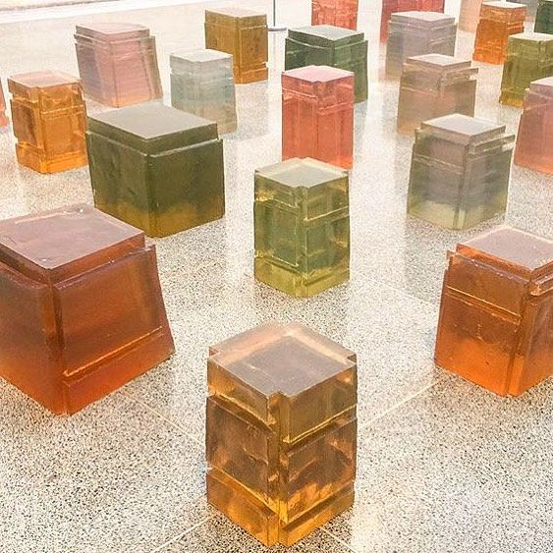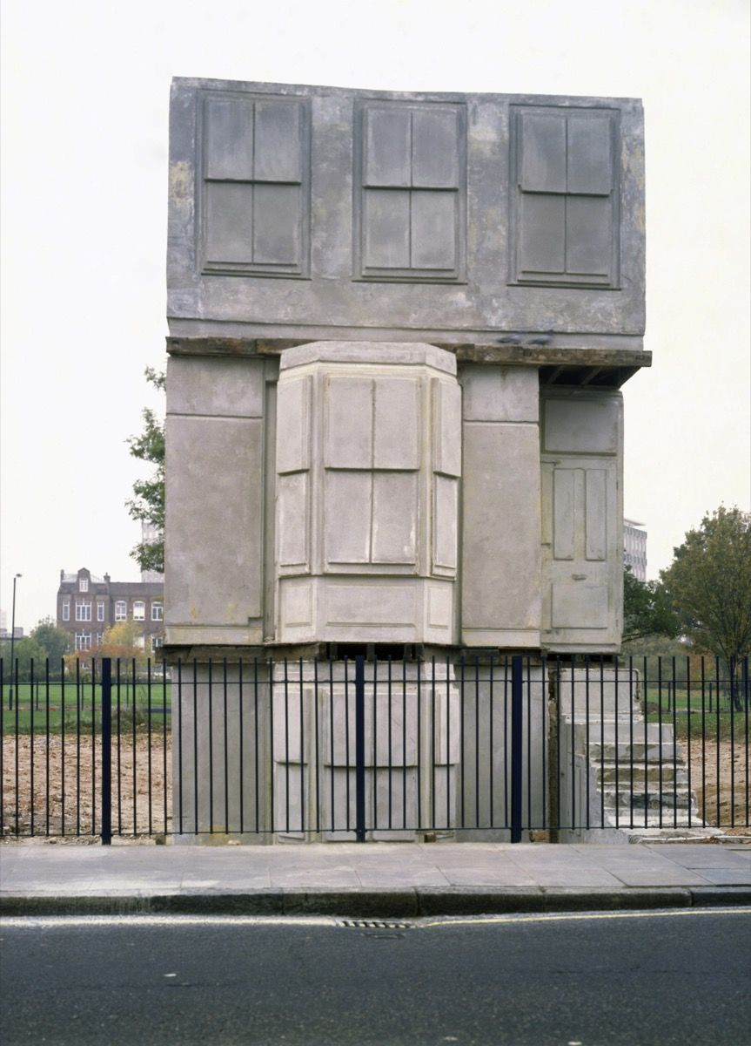
The YBA artist, Racheal Whiteread produced a vast body of work exploring the idea of negative space – the space underneath, the space that is ignored. She cast the space underneath chairs and tables in various materials, creating beautiful plinth and monument-like free standing sculptures. Casting the inside of hot water bottle produced fascinating results and her most ambitious project to date, ‘House’, saw her cast the inside of a house in concrete resulting in a stunning inverted version of a period property in London.
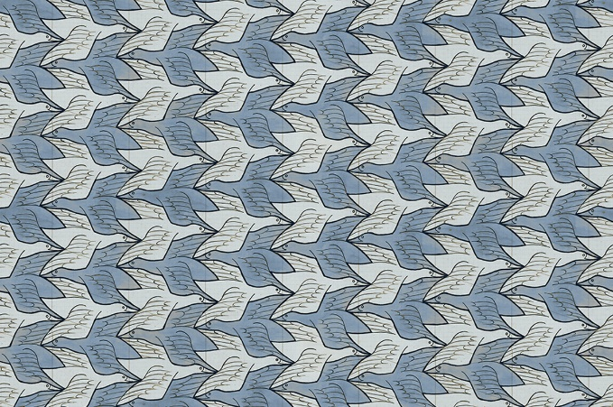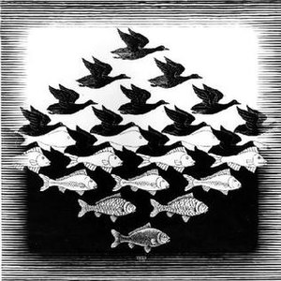
Someone like MC Esher eplores the term ‘negative space’ in a very graphic way. He creates complex tesselating images that can be read from various view points, playing around with perspective and optical illusion. It is often clear that he is representing one animal or feature running in one direction but it is only when you further investigate is it clear that another form occupies the negative space too.
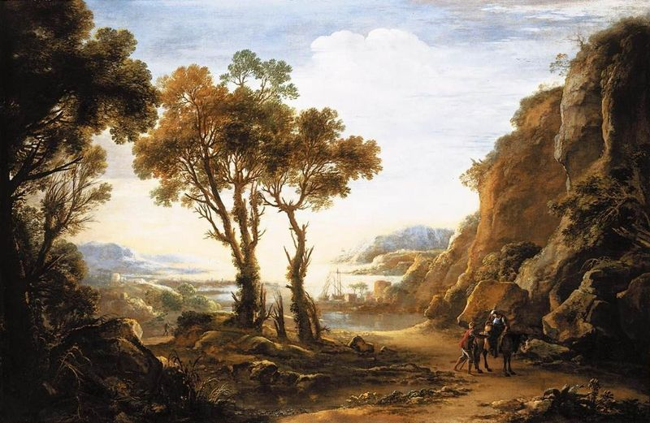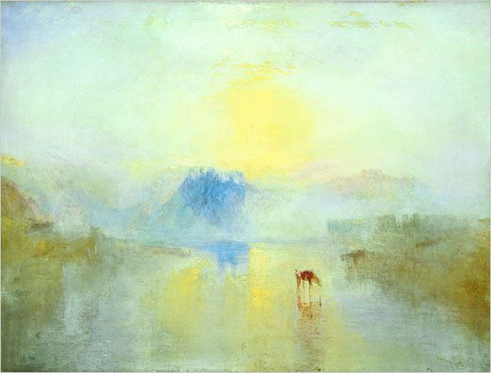
Claude Lorrain was the first artist to use landscape as the sole focus of a painting. Previously in art history, landscapes formed the backdrop to portraits of notable individuals sitting for their portrait. This ‘negative space’ in the background was then often filled with the land around their estate or something more exotic referring to their power to travel the world. Lorrain’s landscapes were accepted for their stand alone beauty without a human focus. This led to JMW Turner and his vast, energy-filled paintings of skies and seascapes, focusing on what might be described also as ‘negative space’ or the space in between points of interest and what we are really looking at. Turner allegedly tied himself to the mast of a ship in a storm so he could feel the elements of wind and rain in order to be able to paint it properly.

Now you have a few ways of tackling this, think about what interests you. Your work should be original and focus on something that you know well and can access easily – a bedroom space for example. Challenge yourself. Move out of your comfort zone – if you are renowned for your drawing, paint. Usually work small, work big, etc.

