# 

# GCSE A Level German

Transition Booklet

2020

Name: ________________________________________________

Guten Tag!

Firstly, congratulations on finishing Fifth Year!

You can now look forward to a long summer with no pressure of exams.

Secondly, you have made the right choice in continuing to study German … and you will discover why in this booklet.

Work through these tasks over the summer; you don’t have to do them order.

We will look forward to seeing your work in September! Viel Glück!

**Task 1:**

Answer the following questions in English:

1. Describe the importance of the German language in the world.

2. What are the main benefits of studying German?

3. How can the study of a book or a film help you to learn about the German language and culture?

4. Do some research about the countries that speak German other than Germany itself and write some notes here. Is there anything that particularly surprises or interests you?

5. Which cultural aspects of the German speaking world particularly interest you? Festivals in Bavaria? Typical food from Austria? Do some research online and write your thoughts here.

6. Thinking of a particular cultural aspect you are interested in, do some research and summarise your findings below.

7. What do you most like and enjoy about speaking and learning German?

8. List 10 reasons why you should learn German:

**Task 2:**

Prepare a “fact sheet” or a set of revision cards etc on 3 of the following tenses (we would encourage you to pick 3 tenses that you are least sure of!). Please include regulars and the main irregulars. Be creative, imagine you need to use the factsheet to teach someone else about that tense – make it clear, appealing, useful and easy to use!

Present Imperfect Perfect Future Conditional

**Task 3:**

Make a playlist on Spotify (or whatever you use for music) and create a *long* playlist of some German-speaking artists that you will regularly listen to. Here are some to get you started:

Namika

Xavier Nadoo

Die Prinzen

Revolverheld

Glasperlenspiel

**Task 4:**

If you haven’t already, change the language on your phone to German. And make sure you leave it like that.

**Task 5:**

Research and answer the following:

1. **The names of three German newspapers are ...**
2. **The names of three German companies are ...**
3. **The names of three recent German films are ...**
4. **The names of three famous German actors/singers/writers/artists (3 of**
5. **each) are ..**
6. **‘Das Abitur” is …**
7. **Three famous German dishes/foods are…**
8. **Three wine-producing areas are …**
9. **Three German football teams are …**
10. **Three famous German sportspeople are ….**
11. **10.‘ Deutschsprachigen Raum’ means …**
12. **Three former German kings or queens….**
13. **Three countries where German is spoken …**
14. **The name of the German equivalent to British Rail is ….**
15. **ICE stands for ….**
16. **The German Chancellor is ….**
17. **Three sports the German speakers love…..**
18. **The name of the German person in power when the Berlin wall was**
19. **erected….**
20. **The name of the German person in power when the Berlin wall came down….**
21. **Three German political parties ….**
22. **Three major German companies with offices in London…**

**Task 6:**

Watch at least 2 films or a few programmes in German – **Netflix** is a good source! Write a short summary or review auf Deutsch here:

**Task 7:**

Independent learning! Do anything else you would like to do; you could find an interesting article and translate it, find some song lyrics and translate them, watch a YouTube video on a particular grammar point and make some flashcards, get back on Quizlet and play some games – whatever you like! As you know, little and often is the key…

**Task 8:**

Lastly, write yourself a “mission statement” for your A Level German journey; what are you going to endeavour to do over the next 2 years to help you with the A Level German course? What do you hope to achieve? What do you hope to get out of the next two years?

[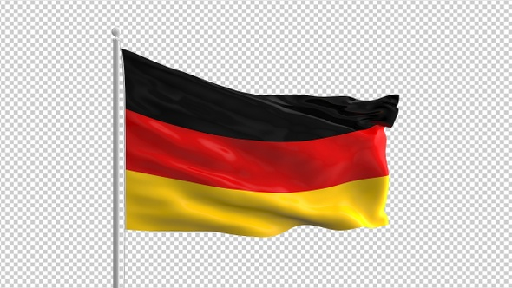](https://www.google.co.uk/url?sa=i&rct=j&q=&esrc=s&source=images&cd=&ved=2ahUKEwjvqpDppvriAhUQExQKHeCRBZQQjRx6BAgBEAU&url=https%3A%2F%2Fvideohive.net%2Fitem%2Fgerman-flag%2F23469108&psig=AOvVaw0jhIrYXhn5w4rc_HmG9yJI&ust=1561197168381185)

**We are very much looking forward to welcoming you back in September; have a fantastic summer holiday!**