**Galleries Interpretation Task**

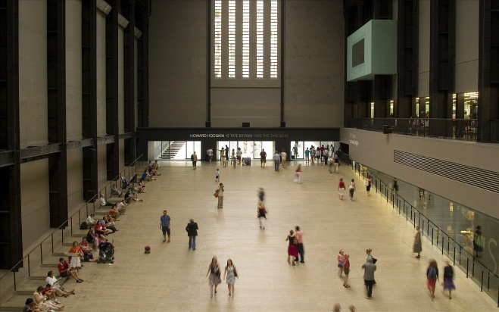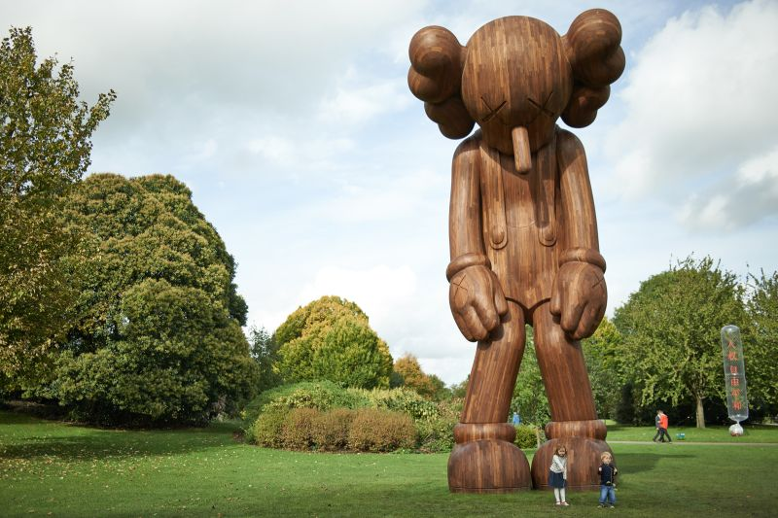

Using the list below, we want you to pay a visit to one of the galleries. Find a piece of work in there that resonates with you. It might be something that reminds you of home or your family, something that depicts a place you would like to visit, an event in history or something that provokes an emotional response – anger/sadness/happiness/confusion/disbelief – anything that attracts your attention. People often get frustrated in art galleries if there is work that they don’t fully understand or they feel alienates them. This is normal – you will not like every piece of work in a gallery, just like you will not like every minute of a movie or a performance. Stick to what interests you – this might be because of the skill showed by the artist or the feeling that a piece of work gives you. It might even make you laugh!

Choose your artwork. Write down the title, name of the artist, date and some quick responses/initial thoughts that you have to the piece of work.

Now produce some sketches or take photographs of this. They might be quick sketches immediately in front of the piece or more detailed drawings afterwards. You might want to focus on a specific area of a painting for example or photograph each section closely to piece back together once you get home.

Using an art medium (drawing, painting, sculpture) or focusing on photography, we want you to interpret the piece of work in your own, personal way.

**THIS MUST NOT BE A DIRECT COPY***

You might recreate the scene using contemporary sources to photograph or create a painting from.

You might be inspired by the light in a piece of work and create a series of photos.

You might visit the place where a painting was set and create your own version.

The final work doesn’t have to be one piece of work – it could be a series or an artefact, something more conceptual.

Keep this work together. You will need to plan a little and write about your ideas and process. This should form a small mini project at the start of term.

**Yorkshire:**

York City Art Gallery.

Art of Protest Gallery, Little Stonegate, York.

Hull – The Ferens Gallery and small independent galleries near the dock on Humber Street.

David Hockney gallery at Salts Mill, Saltaire.

Yorkshire Sculpture Park, Wakefield.

Hepworth Gallery, Wakefield.

Leeds Henry Moore Institute, Leeds.

**Further Afield:**

Tate Liverpool, Liverpool.

Abbots Hall, Kendall.

Whitworth Gallery, Manchester.

Manchester City Art Gallery.

The Baltic, Newcastle.

London – Tate Modern, Tate Britain, The RA, The Barbican, The Hayward Gallery, The V and A, Unit, Gagosian, Flowers East, Beers Contemporary, Victoria Miro, Jealous, White Cube, Camden Arts Centre, Lisson Gallery, Serpentine gallery.

Photographers – Visiting big cities can be a great source of inspiration. For example in London places like Kings Cross station, East London (shoreditch, Brick Lane), Camden Lock, the Barbican, the south bank, Trafalger Square and many more are great places to photograph people, architecture and practise technical skills on your camera.

**Europe:**

If you are travelling on holiday over the summer.

Paris – Louvre, Musee de Orsay, Palias de Tokyo, Pompidou, Musee Picasso

Amsterdam – Van Gogh, Riiksmuseum, Street art Museum

Berlin, Barcelona, Rome, Stockholm, Oslo, Vienna, Madrid, Venice, Florence, Lisbon, Naples also have incredible museums and galleries.

