Environmental Design Challenge

Can you reduce the ecological impact of modern furniture?

Tasks:

You will need to research modern furniture to identify the problems are with furniture design and manufacturing.

You will need to find out what compromises the consumer will make and what their expectations are. What do they want?

You will need to find out how furniture is constructed and the materials it is made from. In doing this you will need to consider the environmental impact, each material might have. Do not forget about LIFECYCLE ANALYSIS when you are doing this.

You will need to identify the types of furniture that exist be it seating, storage or sleeping and then work out what type you want to re-design.

You will then need to carry out sketching and lightweight modelling, very much as you did in the chaise lounge project to explore styling and form.

Iterative designing is an area that pupils tend to struggle with at GCSE and at A level. You need to build your understanding of this important design process and improve your skills in using this as a tool. To help you have a look at the two links below, before you start your own design work:

<http://fortune.com/2016/10/03/billionaire-inventor-james-dyson-on-his-tedious-creative-process/>

<https://www.theguardian.com/culture/2016/may/24/interview-james-dyson-vacuum-cleaner>

User opinion?

Evaluation process throughout.

Ergonomics?

Product safety? Flammability is a big one with furniture.

Dimensions?

Construction?

Materials choices?

Finishes? Linked to the users aesthetics preferences.

3D Cad modelling using sketchup or Solidworks

Solidworks link to download student copy:

<https://pocklington.fireflycloud.net/subjects-1/design/using-computer-aided-design>  
  
SDK ID: 92018SDK They will need to input the 2018/2019 version

Sketchup link:

Sketchups on line Free software. You will need to use this link and create a log in, just follow the simple instructions, <https://www.sketchup.com/plans-and-pricing/sketchup-free>. There are plenty of youtube tutorials to help you get used to it.

Other research resources:

[www.Dezeen.com](http://www.Dezeen.com)

[www.designmuseum.org/design](http://www.designmuseum.org/design)

[www.vam.ac.uk](http://www.vam.ac.uk/)

[www.sciencemuseum.org.uk](http://www.sciencemuseum.org.uk/)

<https://www.designcouncil.org.uk/>

<https://fsc.org/en>

**Some starting points**

The main environmental concerns of the wood-based furniture industry include the following:(i)air pollution from sawdust, other particulates, and VOCs;(ii)water pollution from used solvents and other spent finishing materials as well as from maintenance and clean-up operations and(iii)solid wastes comprising of wood chips, sawdust, adhesive and resin particles, and general trash (Table [1](https://www.hindawi.com/journals/tswj/2014/596958/tab1/)).

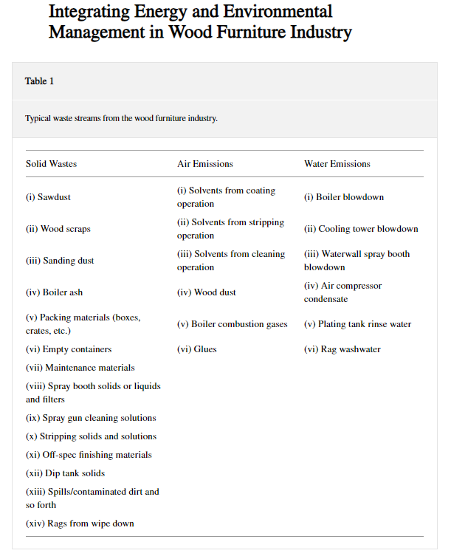

Continual environmental pollution, fear of complete exhaustion of natural resources, increased public interest for preserving the environment, lack of organized and systematic monitoring of pollution consequences, and specific working conditions in the affected areas have led to the obvious need for the introduction of environmental management systems that are defined by standards, such as international ISO 14001:2004 and the EU - EMAS (Eco-Management and Audit Scheme) [8, 9].

The above was taken from:

Volume 2014 |Article ID 596958 | 18 pages | <https://doi.org/10.1155/2014/596958>

**Integrating Energy and Environmental Management in Wood Furniture Industry**

**Dušan Gordić**,1 Milun Babić,1 Dubravka Jelić,1 Davor Konćalović,1 and Vladimir Vukašinović1

**Aim:**

To produce a folder of research, sketches, lightweight physical models, construction details, dimensioned working drawings, materials lists and CAD models to solve a very open-ended ecological based problem that would allow a third party to make your produce at full size for testing. All decision making needs to be backed by evidence, justified and recorded.

There should be more sketched than words ie no big blocks of text but lots of sketching, diagrams photos and evidence of CAD.

Research should be primary – ie you doing so if you are going to work out measurements then there should be evidence of you measuring a piece of furniture.