

Ethics

In the Lower Sixth, broadly speaking, this side of the course can be divided up into the following two areas:

* 1. Moral Theories: In other words, we will look at three very different approaches of how to work out what makes an action right or wrong.
  2. Application of Moral Theories: Having understood those theories, we will then apply them to different moral issues. As well as helping to understand and evaluate the different moral theories, you will also learn a great deal about some contentious issues and develop your own personal views about them.

Useful transition work for A level will focus on developing a basic understanding of the moral theories / approaches and spending time researching some of the many issues you will cover in the Lower Sixth Year.

**Moral Theories**

Read the introduction to the three moral theories below. Below that, I have listed some suggested reading, listening and viewing of a range of resources that should prove really helpful (and interesting, I hope!) in building your understanding of Moral Theory.

Here's a brief overview of the three different ways of establishing what constitutes 'right' or 'wrong' actions.

1. Deontological Moral Theories: The word 'deontological' comes from the Greek and relates to a 'duty to law'.  This type of moral approach establishes universal laws that are considered 'right'  in themselves – so they should always be followed – no matter what. The 'rightness' of the action does not relate to that action's consequences in any particular situation.  So, once we establish a rule or law such as 'killing an innocent human being is wrong', then the deontologist would say that it is always wrong to break that law because the act is 'intrinsically' wrong, wrong in itself - just plain wrong. A no-nonsense approach to moral decision-making that isn’t everyone’s cup of tea, but it has its strengths and many supporters.

**Examples of Deontological approaches**: Kantian Ethics; Divine Command; Roman Catholic Natural Moral Law;

1. Teleological Moral Theories: The Greek word 'Telos' means 'goal' or 'end'. Teleological moral approaches are very different from Deontological ones. Teleological theories see 'right action' as that which achieves (results in) the 'good' or goal towards which, the theory states, we should all aim. For example, Bentham and Mill believed that 'happiness' is the goal towards which all actions should aim so right action is that which brings about this goal - if my action is the one that maximises happiness, then it's the right thing to do.  Note here that it is not the action that is right or wrong in itself (as with deontological approaches), instead, it is the consequences of actions that determine 'right' and 'wrong'. Killing an innocent human being is ***not wrong intrinsically***, in a particular situation (for example killing one person to save a hundred other innocent lives) it could be the right, the moral thing to do. More often than not, Teleological theories are also 'consequential' - i.e. they examine the consequences of actions in determining their ethicality.

**Examples of Teleological, Consequential approaches:** Utilitarianism (Bentham, Mill), Situation Ethics (Fletcher).

1. Virtue Ethics: A third category of ethical theory has ancient Greek origins. Aristotle is it's most famous proponent and founder. In a sense, it is teleological insofar that it believes that right action is that which leads to the ultimate human goal  - Eudaimonia or 'flourishing' - this is what we all want - it will make us truly happy. By acquiring virtues (moral ones and intellectual ones) through practice and learning we will become virtuous, flourishing people. To lead a 'good life' is to act virtuously and become virtuous. The virtuous person (having been educated and practised in acting virtuously) will act in the right way in the situation because they will respond rationally to the emotions they feel and reflect on the factors particular to the situation....it takes a long time to become virtuous, it's a life's work.

[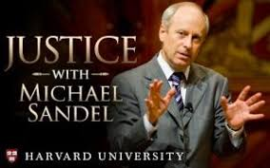](https://pocklington.fireflycloud.net/subjects-1/religious-studies-/the-new-a-level-course/ethics-1)

**Watch, enjoy, note down key thoughts and reflections in preparation for our seminars.**

* + 1. **Michael Sandel’s Justice, A Citizen’s Guide to the 21st Century.**

Headed by Harvard Professor, Michael Sandel.  Watch this excellent documentary to gain a real insight into contrasting moral approaches and how they influence moral decision-making  - and society as a whole.

* + 1. 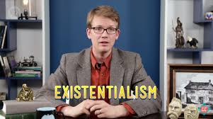**Crash-course in Philosophy is a very reliable and engagingly presented series of ‘lectures’ by Hank Green.**

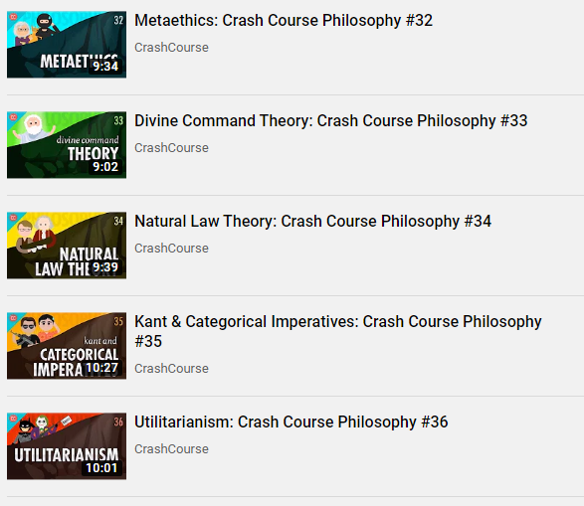

The following link takes you to the whole series of ten minute videos. They are really enjoyable and cover a huge range of topics, so watch as many as you like – **but focus on the following episodes (take them one at a time, don’t do them all in one go!)**

<https://www.youtube.com/playlist?list=PL8dPuuaLjXtNgK6MZucdYldNkMybYIHKR>

**Read…**

A copy of Peter Vardy’s Puzzle of Ethics is perhaps one of the most popular introductions to Ethics. It is well written and accessible. If you do not want to buy your own copy, the department may be able to supply you with one.

You can read it from start to finish, but as a minimum, reading the following chapter will give you a very solid understanding in the areas most relevant to our course:

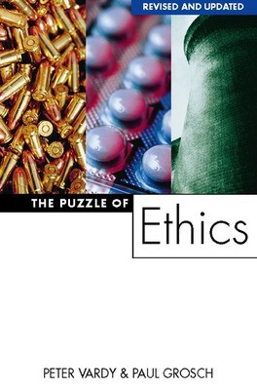**Moral Theories**

**Chapter 1: Setting the scene**

**Chapter 3: Aristotle and Virtue Theory**

**Chapter 4: Aquinas, Natural Moral Law and Proportionalism**

**Chapter 10: Situation Ethics**

**Listen…**

**The following podcasts are real insights into a number of interesting areas related to the theories and issues we are going to be looking at. Have a listen in the car, when you’re on a run or when you are doing some recreational baking.**

* 1. **BBC In Our Time Podcast on Aquinas**

<https://www.bbc.co.uk/programmes/b00mkd63>

* 1. **Philosophy Bites interview with Terence Irwin on Aristotle**

<https://hwcdn.libsyn.com/p/d/0/6/d0698bf7d5b09910/Terence_Irwin.mp3?c_id=1779592&cs_id=1779592&expiration=1588717685&hwt=98929811c435529e885b8dedd751b147>

* 1. **The Moral Maze (BBC Radio 4) – search the back catalogue for debates on the issues we will be covering throughout the course. Listening to discussions about a topic can be a really helpful way into understanding the key issues and may also help you arrive at your own point of view. There are lots of things here, but relevant episodes can be found on:**

<https://www.bbc.co.uk/programmes/b006qk11>