**Year 1 A Level Economics**

**5th Form Transition Worksheet**

Welcome to Economics.

The following activities reviews the economics of the current coronavirus pandemic and global economic crisis.

The videos and research activities are designed to encourage you to think about how the coronavirus pandemic has an impact on so many different parts of the economic system both at a local, national and international level. Whilst following the activities it will introduce you to how to think like an Economist and the type of topics you will be studying from next year.

**Activity 1**

Watch Video 1 - <https://youtu.be/TWdr6nAQNVI> or on Firefly

|  |  |
| --- | --- |
| In your own words explain what is meant by Microeconomics | In your own words explain what is meant by Macroeconomics |
|  |  |

1. What Microeconomic decision did the owners of Primark make that has led them to selling nothing?

<https://www.bbc.co.uk/news/business-52365191>

1. What is the Macroeconomic effect on Bangladesh of the closing of clothing stores during the lockdown?

<https://www.dw.com/en/coronavirus-bangladeshs-garment-industry-risks-collapse/a-52917410>

1. Research for Micro – Can you make a list of other products which people or businesses are buying more or less of ?

|  |  |
| --- | --- |
| Demanded more during the crisis | Demanded less during the crisis |
|  |  |

1. Research for Macro

Can you find newstories that show the Macroeconomic effects of the Coronavirus on a country under the following headings

1. ***Unemployment***
2. ***Recession***
3. ***Government borrowing***

**Activity 2**

Recap - Using your Knowledge from Activity 1 – Can you tell whether the following headlines are related to Microeconomics or Macroeconomics? Write Micro or Macro

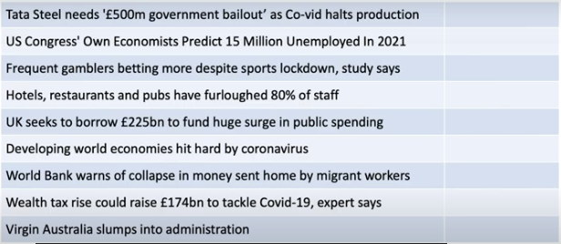

1. Watch Video 2 - <https://youtu.be/GH4dagUDons>.

Were you correct? Make a note of any headlines you didn’t understand.

Think - Why are Micro and Macro economic issues linked?

**Activity 3**

1. What is GDP? Find out here <https://www.youtube.com/watch?v=hBqWRayc1kE>
2. Research- What is an emerging market? Can you write down 5 examples.

1.

2.

3.

4.

5

**Challenge**

Pick one of your countries listed above and research how the Coronavirus is affecting this country?

**Activity 4- Presentation**

Please create a PowerPoint that you can present to your new classmates in the first week of your new A level course

**Introduction -** Watch the following Video [**https://youtu.be/9nrZwjcjS1A**](https://youtu.be/9nrZwjcjS1A)**.**

Highlight with some of your own research the economic effects of the Coronavirus pandemic.

**Slide 2 – Emerging Market**

Develop your introduction by explaining how it has impacted on the country you studied in Activity 3

Watch video 4 **-** [**https://youtu.be/MCGmPRSkmJ4**](https://youtu.be/MCGmPRSkmJ4)

**Slide 3 – What has the UK Government and the Bank of England done to help the Economy?**

Highlight some of the things the government has done to help the economy such as the furlough scheme- Be prepared to explain how these will or are helping

**Slide 4- Conclusion - Has the government done enough?**

In your opinion has the Government done enough? Is there anything else they could be doing? Perhaps compare to another countries economic response.

What is the problem with what the government has been forced to do?

Prediction- What might happen to the Economy next? How did you come to this decision.