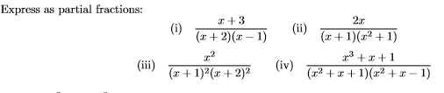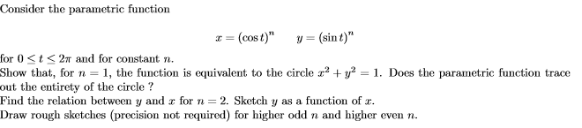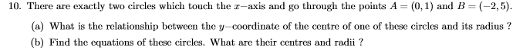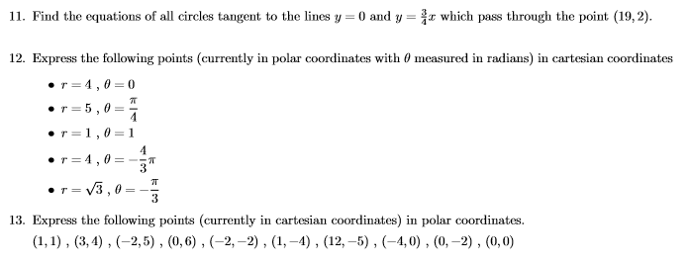

1.

**University style maths questions from a 1st year science course:**

You may need to research a few ideas to answer them.

7.

6.

5.

4.

3.

2.

8.



9.

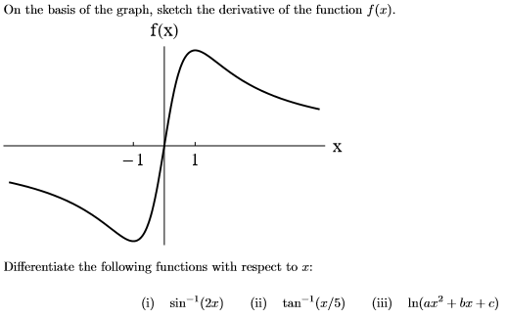

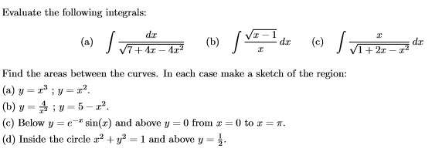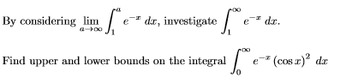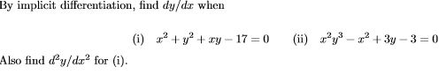 

16.

14.

15.

13.

12.

11.

10.

17.

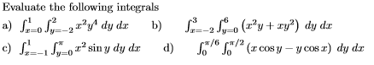

18.

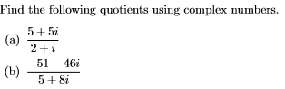

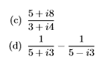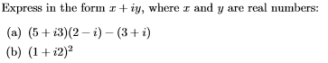

19.

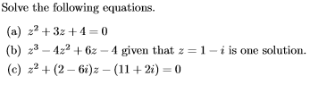

20.