**L6th ART**

Artists are resourceful and alongside working from images on the internet, more than ever, we need to appreciate and use what is around us. Drawing or working from something in front of you is so much more valuable than working from a second hand image.

Therefore, I want you to produce 3 drawings focusing on a single subject that it is front of you. You could look at yourself in the mirror, the view from your window, the light coming through the curtains or plants in your garden. Artists get better and more confident in their practice by looking at the same subject many times. Artists like Rembrant and his evolving self portraits, Georgio Morandi and his focus on simple still life compositions and David Hockney looking at the reflections in swimming pools.

**Set of 3 drawings that lead to a painting.**

Hopefully you all have some way to paint – acrylic, oils, watercolour, ink.

I want you to work on 3 detailed drawing studies in your chosen media – simple pencil, ink, biro, fineliner, etc. They shouldn’t be exactly the same for all three, slightly change the angle, lighting, expression or viewpoint.

Once these 3 drawings have been produced you then need to create a more refined painting from one of the drawings. This could be on a larger scale if you have room/materials or smaller, your choice. You will have learned a lot about the subject through drawing it and hopefully gained in confidence – that needs to show in your final painting.

Choose the subject carefully!

Rembrant

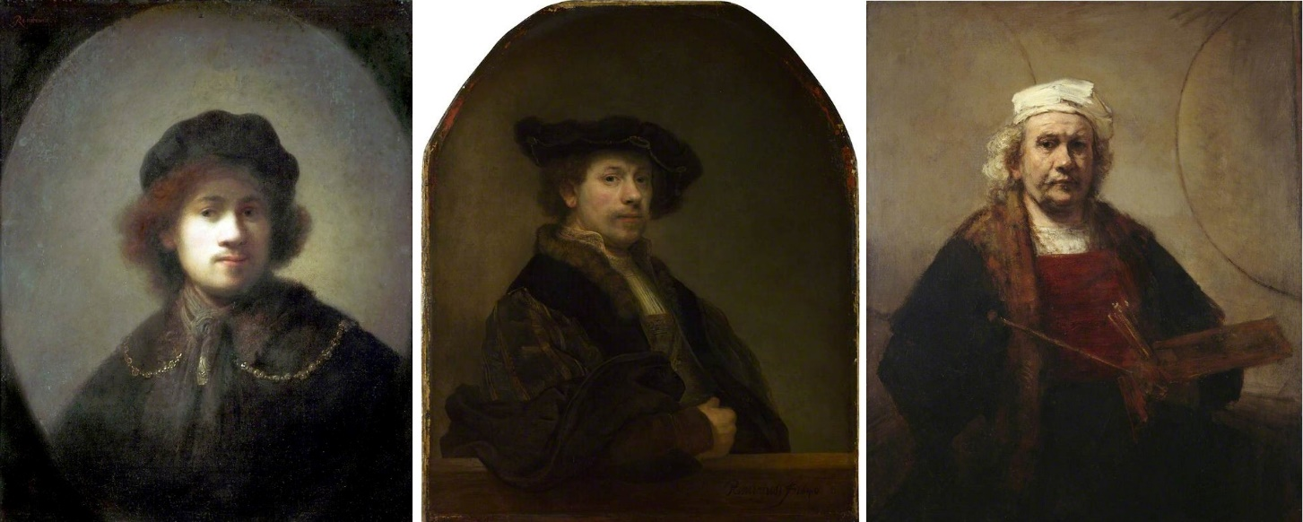

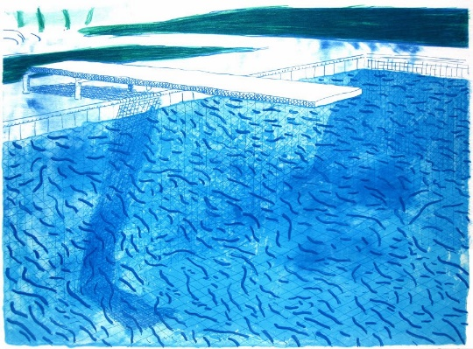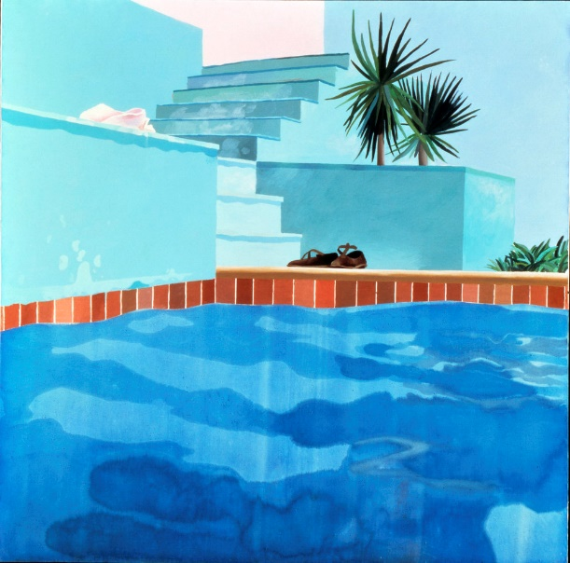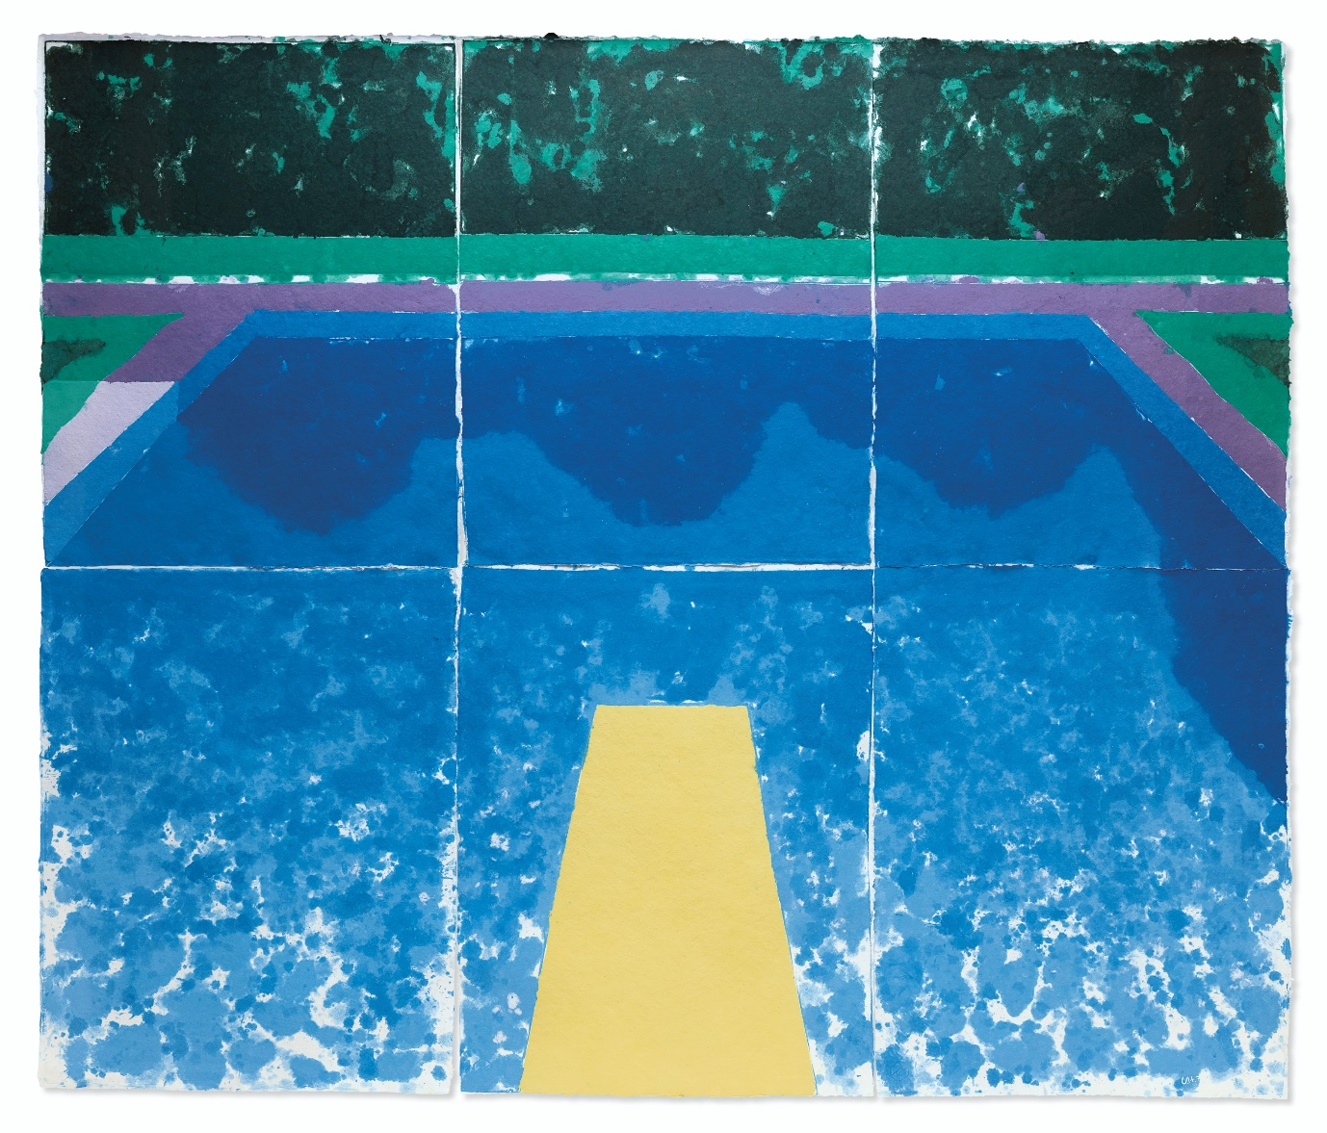Hockney

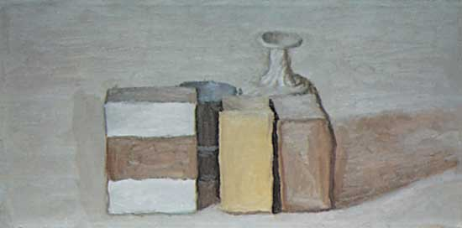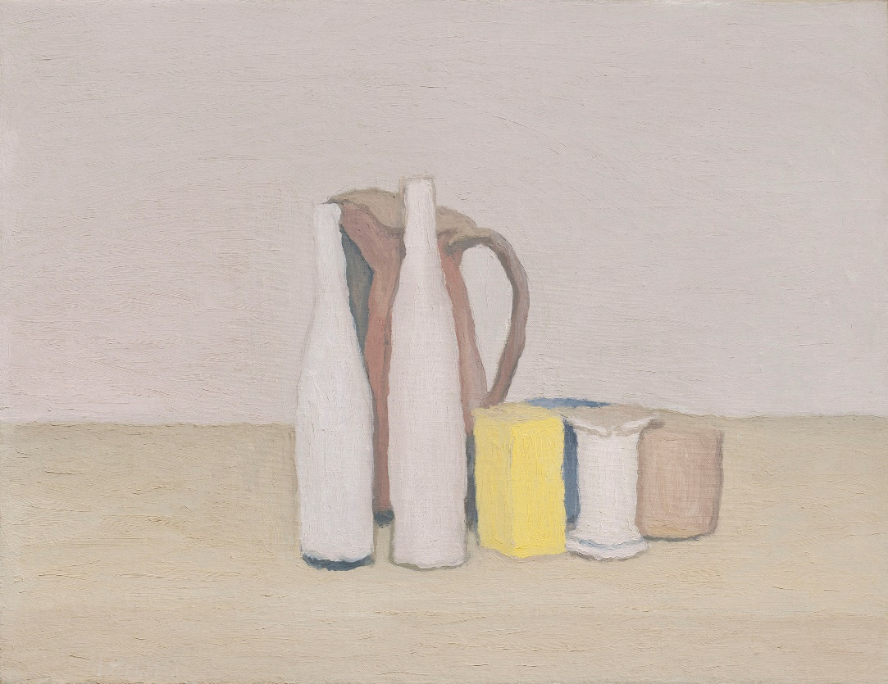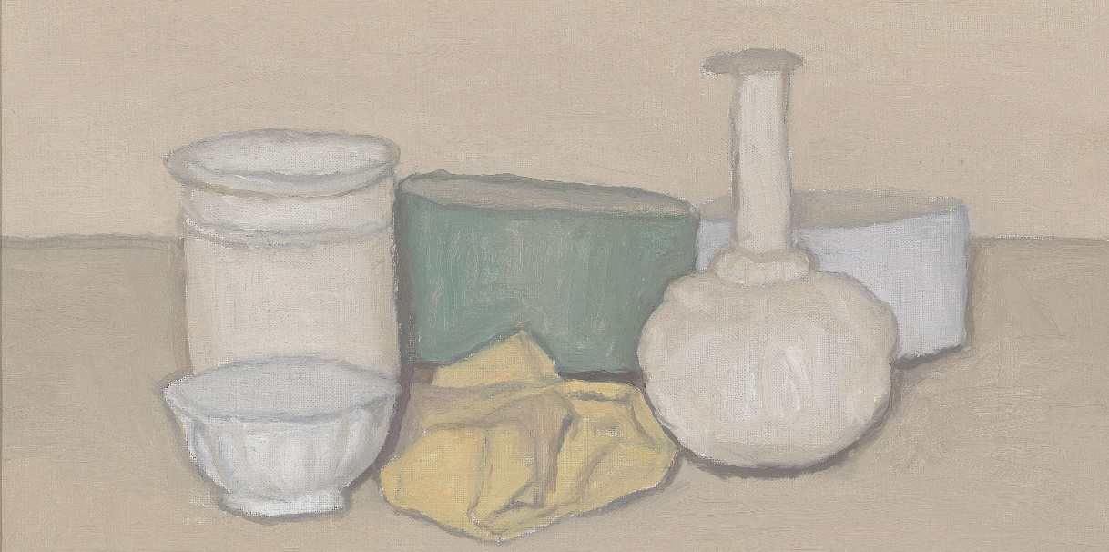

Morandi