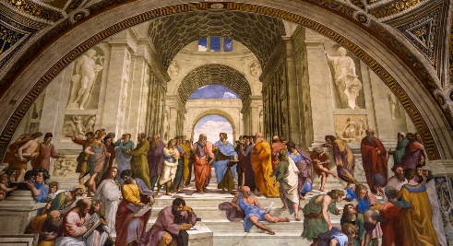

Philosophy

**Compulsory tasks:**

Please research the following three arguments for the existence of God:

* Ontological Argument (by Anselm)
* The Third Way of the Cosmological Argument (by Aquinas)
* Teleological Argument (by Paley).

Once you have done this, make **3 separate A4 posters** to explain these three arguments. Use colour and illustrations to make the information more appealing to learn!

On the back of each poster, research and write down some **strengths and weaknesses** of each of these arguments.

This will put you in a very good position when starting the course in September.

**If you wish to push yourselves further…**

* There are now three series of “**The Story of God**” by Morgan Freeman on Netflix. These are certainly worth watching, as the titles of each episode are very similar (if not the same) to the topics on this course.
* I highly recommend that you read “**The Puzzle of God**” by Peter Vardy, as this gives a great overview of Philosophy (and many of the topics that we will be studying, too). You may want to make a few notes as you read, too.
* Another great read is “**Sophie’s World**” by Jostein Gaarder. This was recommended to me when I was studying for my Philosophy A-level. It is a novel, but it also gives insight into the history of Philosophy.
* Other recommended reads…

Blackburn, S. *Think*, OUP 2001

Craig, E. Philosophy: *A Very Short Introduction*, OUP 2002

Law, S. *The Philosophy Files*, Orion 2002; The Outer Limits, Orion 2003; The Philosophy Gym, Hodder Headline 2003

Nagel, T. *What Does It All Mean?*, OUP 1987 (reprinted 2004)

Warburton, N. Philosophy: *The Basics* (5th ed.), Routledge 2012

Davies, B. *An Introduction to the Philosophy of Religion*, OUP 1993

* One to listen to…this episode of ‘In Our Time’. <http://www.bbc.co.uk/programmes/b01mwx64> Based on these arguments, is it possible to argue that God necessarily exists?