**Year 1 A Level Business Studies**

**5th Form Transition Task**

**The Box**

You have been given this cardboard box.

How are you going to turn it into a profitable idea?

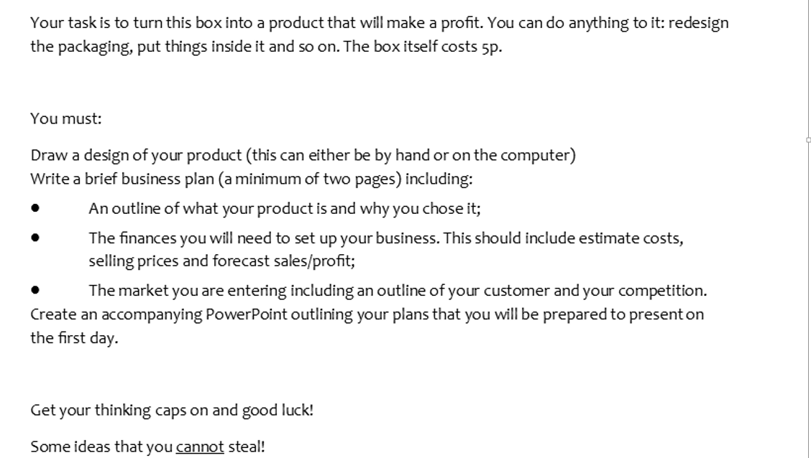



Image result for glossybox[](http://www.bing.com/images/search?q=graze&view=detailv2&adlt=strict&id=0E9C04C53D94BDB25188407DAC0209F13C64D87C&selectedIndex=2&ccid=HeuOchim&simid=608030313479015124&thid=OIP.M1deb8e7218a6fe3ec3d94998c4908431o0)

To help with your *presentation.* Watch an episode of Dragons Den – There is one on firefly or a few episodes of the current series on iPlayer. <https://www.bbc.co.uk/iplayer/episode/m000gxfh/dragons-den-series-17-episode-14>.

Think – What questions do the Dragons ask? Why do they want to know this information?

Activity - Incorporate research to help answer these questions in your presentation.