Transition project 2 – Household object transformation

Create a political art piece using a household object or objects.

You might use one object and embellish or deconstruct this or several pieces to create an installation. You might choose to draw/paint from objects. You might want to photograph a series of objects in a certain way that provokes inquiry. You might create a sculptural piece out of several items together – it is up to you how you tackle the project, there are no boundaries. Be creative!
The piece must be backed up by something that you strongly believe in. Whether this is animal rights, the planet, political bias, thoughts on lockdown and the global pandemic – it is up to you. You might want to explain in more detail what your piece is about – produce a pamphlet to go with it.
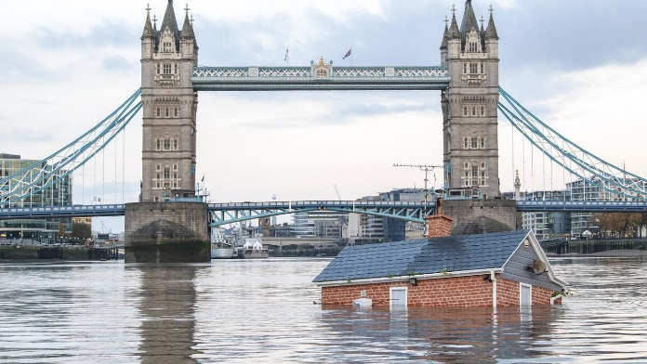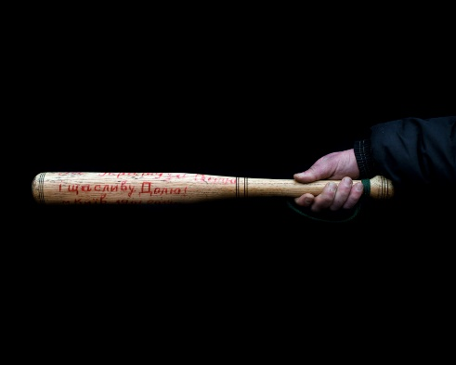
Objects have often been used at political rallies and events to emphasise a point. Recent Extinction Rebellion rallies see people wearing PPE to show the damaging effect we have on the planet and protestors create installation artworks out of plastic waste to support the cause. Famously, they also submerged a house on the Thames. More sinister, fighters in recent flair ups in the Ukraine use baseball bats emblazoned with their political beliefs to beat officials with.
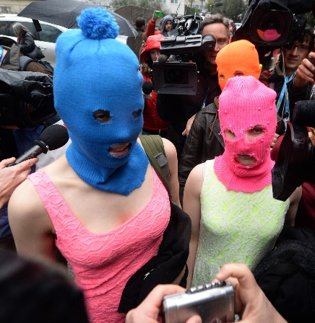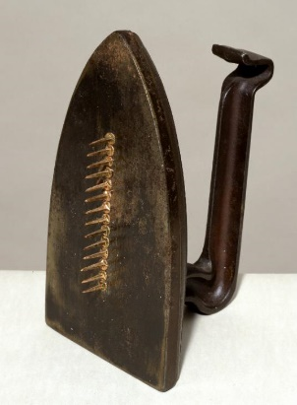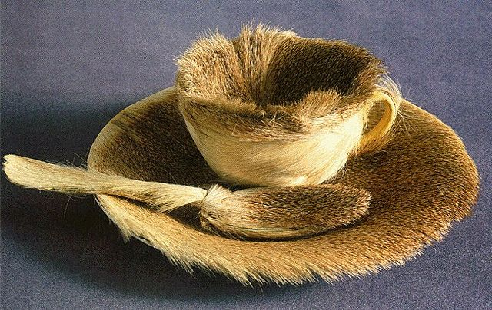
Changing the feel or use of an item can give an object a new meaning. Art activist group Pussy Riot use brightly coloured knitted balaclavas to hide their identity when producing their political art pieces or protesting in the streets of Russia. The balaclava is usually black and the symbol of the military or terrorist group. Man Ray added nails to an iron to transform its meaning from everyday object to sinister weapon. Meret Oppenhein covered a tea cup and saucer in gazelle fur to sexualise the object and rendering it useless as a feminist statement of intent.

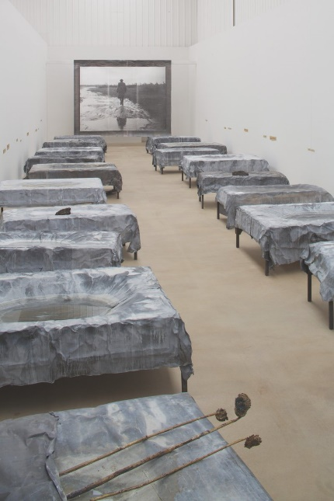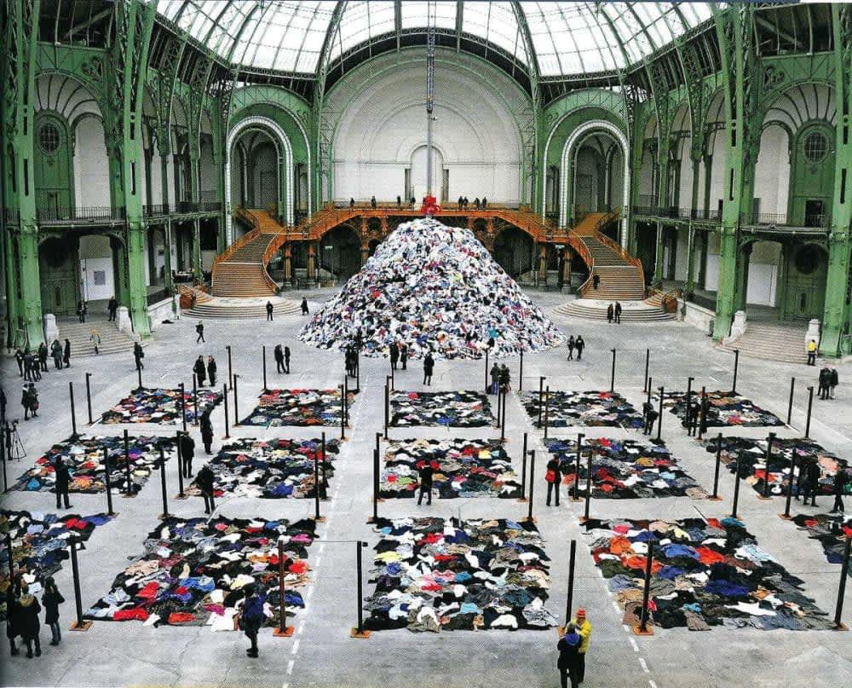
Artists like Anselm Kiefer and Christian Boltanski use many everyday objects in their work to help the viewer empathise with their powerful paintings/art installations based on the second world war and often presented on a monumental scale.
What is the main concept behind your piece of work? What do you want to say?

